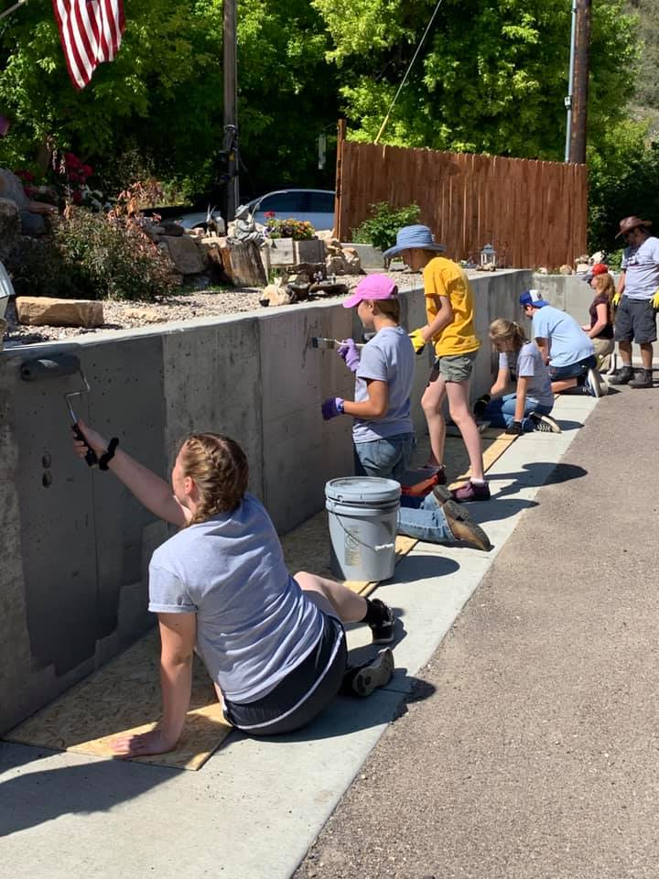

8th Annual   
Mission Trip to Douglas

June 29th- July 2nd

Are you looking for something to do this summer that will give you meaning and purpose? Are you wanting to serve someone else but don't know where to start? Have you ever wanted to go on a mission trip? Why not consider joining a team that will serve right here in Douglas?

Mission Trip to Douglas is an opportunity for youth *13 and older* to serve the residents of Converse County. We will be doing work projects and evangelistic outreach to show the community the Light and Love of Christ. To get the full effect of a mission trip experience, team members will be staying overnight at Unity Christian Fellowship. We will eat together, work together, worship, and be in the Word together. You can expect to participate in everything you would in a traditional mission’s trip without the long flight or the big price tags! There is no cost for MTtD!

“As the people of the church love each other in ways that don’t make sense to the world, they show that the gospel is true. As they love outsiders and welcome them in, the church demonstrates the power of the gospel to change hearts. As they spend their money and their time and their lives pursuing the spread of the gospel, they show what it looks like to have a life that is transformed, set free from the hopeless futility of life without God. The church proclaims the gospel and then lives out the radical, transforming truth of the gospel in its community.”

- Mez McConnell and Mike McKinley

If you are interested in joining us this year, please talk to your pastor, youth pastor, or contact Matt Fox at 359-9365 for more information.